Haptics

Step 3 Implementation Plan

## Goal

Enable Veterans to have a tactile experience in the VA Health and Benefits through the use of vibrations. This will improve the overall navigation experience and improve the app’s accessibility as Veterans can discriminate by touch between objects and navigation.

V1 will use device settings to determine if haptic feedback is on or off within the app while also adding haptics for toggles, error alert boxes, warning alert boxes, and snackbar components.

## Design, Research, & Content

Design, research and content of this project has been completed and consolidated in to the following documents:

* [Product Canvas](https://docs.google.com/presentation/d/1R-q8yHQODV_bgOiSHIbzwnFFfe-4-bka2LwKvPuwKZE/edit#slide=id.p)
* [Feedback Recommendation](https://docs.google.com/document/d/1R-u8PQQXo11-V3mSHTPsH7h_rrXfWKpIJP3nRVJzHY8/edit#heading=h.o1b49rfssykx)
* [Sprint 0 Product Brief](https://docs.google.com/document/d/1b-aGQlAeMWv_nAzafCzU4IRoiuL23dFrwtFWVuOR2PM/edit)

Zero dependencies on functionality, data, or other needs from teams outside the mobile app team.

Design uses existing design and structure of the Setting’s section

* + 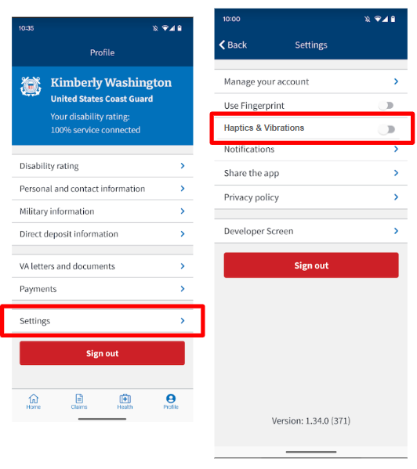

Content requires the naming of the haptics setting. Per a11y, the setting will be called “Haptic vibrations”.

## Process

**Technical Approach**

Haptics changes will be global within the VA Health and Benefits app. Haptics will be added at the component level to improve ease of implementation, testing, and future expansion. We will be using a feature flag for this feature and will be released at 100%.

**Out of Scope**

* Form Field buttons
* Form Field
* Pagination / scrolling
* Bottom Navigation (may differ with Navigation project)
* Buttons
* CTA buttons
* Picker List
* Customer haptics
* A/B testing
* Distinguishing between alert boxes

**QA Strategy**

Testing will include at least the following:

* Haptics default setting is off
* Turning on heavy haptics for toggle on iOS and Android
* Turning on 4 pattern haptics for alerts component in iOS and Android
* Turning off haptics and validating toggle and alerts do not cause haptics in iOS and Android
* Haptics setting remains when leaving and returning to the app
* Validate data is being stored and tracking appropriately

The user story for QA Test Plan can be found [here](https://github.com/department-of-veterans-affairs/va-mobile-app/issues/4528).

**UAT Plan**

Because we are not testing any Veteran-specific data that we are unable to access with test users, we are not planning formal UAT for this feature. If we find any areas during implementation that we see as particularly risky, we will plan extra testing in that area.

**Timeline/Resources**

| **Ticket Estimates** | 8 (X points) |
| --- | --- |
| **Resources Needed** | FE, UX, QA |
| **Est # of Sprints** | 1 for FE |
| **External Team Impacted** | No |
| **Risks** | * Unknown OOO * Priority shift * Bugs / findings while implementing |

**Tickets**

| **Ticket Name** | **Team** | **Ticket Number** |
| --- | --- | --- |
| Epic | Ad Hoc | [4314](https://github.com/department-of-veterans-affairs/va-mobile-app/issues/4314) |
| Setting Title Creation | UX | [4514](https://github.com/department-of-veterans-affairs/va-mobile-app/issues/4514) |
| Setting Creation | FE | [4512](https://github.com/department-of-veterans-affairs/va-mobile-app/issues/4512) |
| Setting Default to Off | FE | [4515](https://github.com/department-of-veterans-affairs/va-mobile-app/issues/4515) |
| Haptics added to Toggle | FE | [4516](https://github.com/department-of-veterans-affairs/va-mobile-app/issues/4516) |
| Haptics added to Alert Box | FE | [4517](https://github.com/department-of-veterans-affairs/va-mobile-app/issues/4517) |
| Haptics added to Snackbar | FE | [4558](https://github.com/department-of-veterans-affairs/va-mobile-app/issues/4558) |
| Data tracking | FE | [4518](https://github.com/department-of-veterans-affairs/va-mobile-app/issues/4518) |
| QA Test Plan | QA | [4528](https://github.com/department-of-veterans-affairs/va-mobile-app/issues/4528) |
| Pre Launch Readiness | Product | [4527](https://github.com/department-of-veterans-affairs/va-mobile-app/issues/4527) |

**Haptics in V1**

| **Error Alert Messages** | 3 pattern |
| --- | --- |
| **Warning Alert Messages** | 3 pattern |
| **Snack Bar** | 3 pattern |
| **Toggles** | Heavy Vibration |

[**Pre-Launch Activities**](https://github.com/department-of-veterans-affairs/va-mobile-app/issues/4527)

**App Store Updates**

Update the What's New section to include information on this feature. App’s description or images will not be impacted. This [user story](https://github.com/department-of-veterans-affairs/va-mobile-app/issues/4527) will track this work.

**Call Center Documentation**

Call Center documentation will be updated once closer to completion of the feature. This [user story](https://github.com/department-of-veterans-affairs/va-mobile-app/issues/4527) will track this work.

**Release Notes**

Release Notes will be written once closer to completion of the feature. This [user story](https://github.com/department-of-veterans-affairs/va-mobile-app/issues/4527) will track this work.

**Post Launch**

Verify data tracking is working successfully in production. Additionally track and review metrics for haptics use in order to plot future enhancements. Review App Store reviews for references to haptics. Note data tracking may not exist or be limited for V1 as we are using the device’s settings and not creating our own.

Review expanding haptics and overlapping with data in order to prioritize future enhancements.

**Stakeholders**

* VA Mobile POs - Chris Johnston & Rachel Han
  + This feature involves changes to in-app functionality only so external groups should not need to be notified, apart from updating the [VA App Store](https://mobile.va.gov/app/va-health-and-benefits) content and updating Call Centers.

## Step 3 Gate Review

Once the implementation of this feature is mostly complete, we will have the Step 3 Gate Review to discuss moving to Step 4 (Launch). During that review we will do the following:

* Will occur at the SoS meeting
* Review any bugs that we will launch with
* Review phased release plan
* Review success measures and monitoring plan

## Questions

* *Are we going to change what’s an <AlertBox> vs not (I’m assuming no, that’s not in scope)?.*
  + No change to what an alert box is
* *If no to #1, since we’ll have the ability to decide on a per-case basis (using the parameter Jon mentioned) whether an alert has haptics, do we have any guidance on “this thing that’s styled as an alert but isn’t functioning as an alert shouldn’t get haptics” or are we just applying them universally? (Again, guessing the latter)*
  + Applying it to the components universally to start with
* *If applying universally, I’d still want to collect “things that are currently alertboxes that don’t seem very alert-y” into a lower priority follow-up ticket for consideration/discussion. Adam do you have a preference on that?*
  + *Bini pulled a list. Shared with Brea and Therese.*
* *Haptics being applied to all alertboxes?*
  + *Haptics only being applied to error and warning alert boxes*

## Updates made post Step 3 for Step 4

* Identified we needed to shift strategy and use phone settings
  + So to turn off haptics in the app then have to turn it off on the phone’s settings
  + Phone settings use different verbiage and locations for haptic settings as it differs by device and OS version
  + Not all devices support haptics, ex iPads
* We did not have 4 pattern haptics in our library and either iOS or Android did not support it so decided to do 3 pattern haptics
* Build this around a feature flag to toggle on and off if need be
* Will be releasing at the same time as Navigation
* Some efforts shifted mid development (mid-Feb) due to phone settings needing to be included / involved when originally thought out of scope
  + This led to some development not being used and scrapped
* Went the route of using the device’s and OS’s settings as that is the direction the app wants to go - it aligns with how the app handles Dark Mode
  + If we had went the notification route there would have been a couple days of unplanned work , in addition to not moving in the direction of using the device’s settings vs creating our own
* Because of the changes we also lose insight into analytics as we are not watching them toggle